How to use voting service.

Register of the candidate or voter:

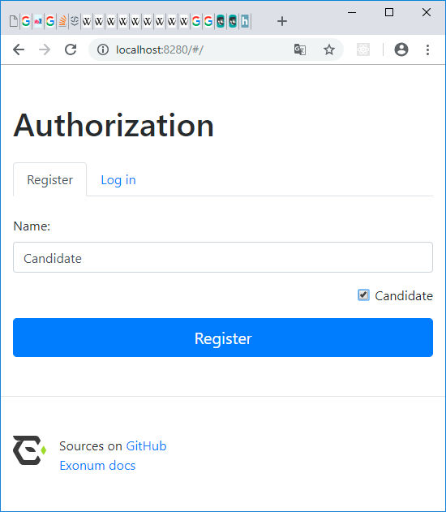

Candidate:

Input candidates name, check “Candidate” checkbox and press “Register” button.

Voter:

Input voter name, do not check “Candidate” checkbox and press “Register” button.

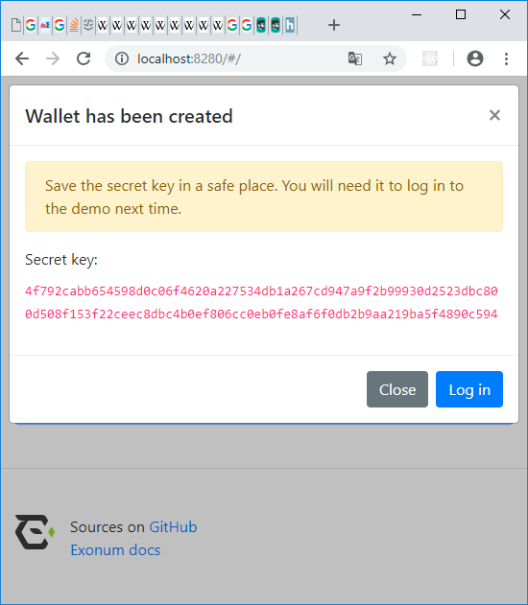

Pop-up window will appear with a secret key which will be used as a passcode for next login. So copy it.

Press “Log in” button to access your wallet.

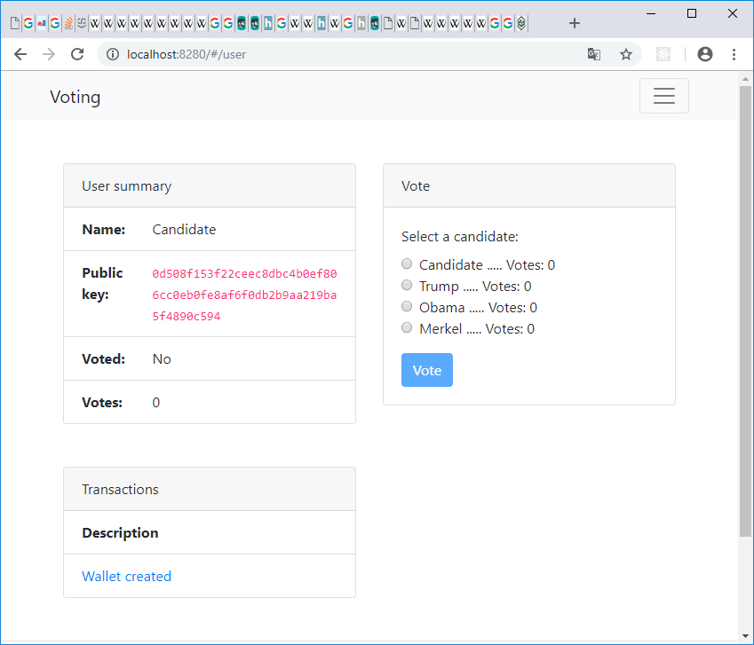

Voting:

To vote select a Candidate on “Vote” block and press “Vote” button.